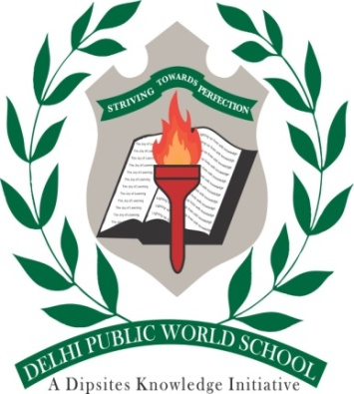

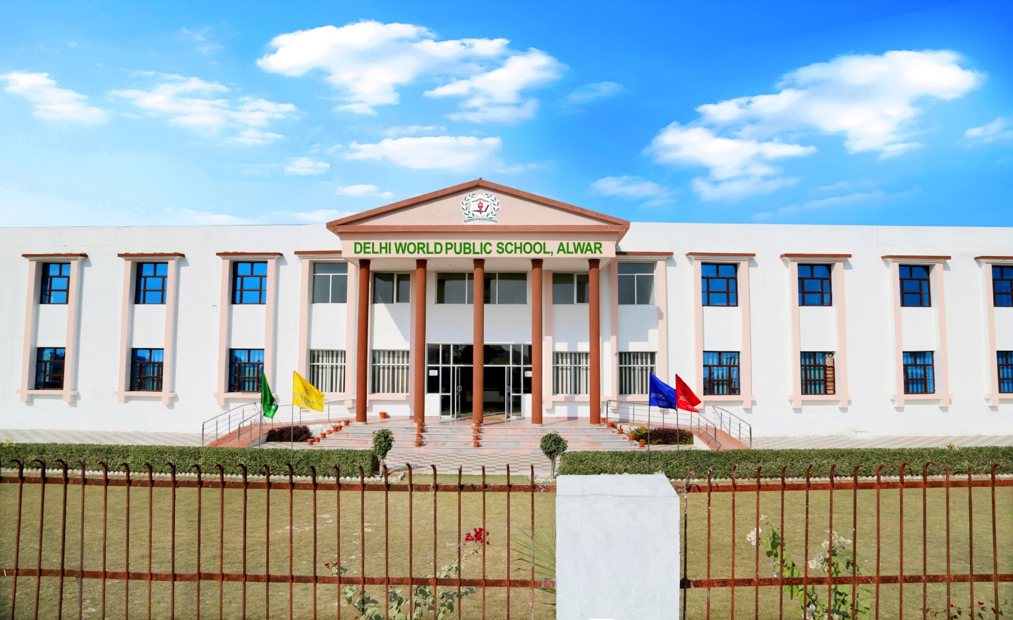

ANNUAL REPORT
SESSION- 2020-21

“May be there is a road ahead of it,
May be there is new world the road,
Waking forth is the only plight,
Because we did not come this far to come this far only.

A heartfelt and filled with aspirations is all that we know since the very existence of the school and that is what gave us the ambition of marching forward till excellence is achieved is annual report.

The Annual report compnsed of the achievements made during the year gone by end at the same time set the path for greater accomplishments in the years to come.

- Not as a regular year, the session began with the lockdown conditions due to covid-19 pandemic situation.
Hurdle was only to teach the students at their home, school started the online classes with the help of “MICROSOFT TEAMS” for the complete session and it was done through a rigorous training schedules and training sessions provided to both parents and teachers.

All things were made Digital.
- School also conducted the online examinations for the students with proper guidance under supervision of teachers.
- Important days, National festivals and many more competitions took place through the virtual mode to build and motivate the enthusiasm of students is co-curricular activities as well.

- School also participated in Delhi World Foundation Inter School competition organized by joint efforts of foundation and Delhi World Public School, Ajmer.

In which our school students Lavyanshi Khadolia and Tarini Gupta made up pride by securing 3rd position.

In this competition around 82 schools of foundation participated and average of 250 students were taking part in a single event.

- Teachers day celebration and children day celebration was not forgotten by school. Through virtual mode both took place special funny games were played and jokes were cracked.

- During the complete session students were involved only in the Academic related activities which was new for them is this session. To develop a space of freedom from academics and increase creativity in the students.

School organised various FOOD COOKING WITHOUT FIRE & MIND INTELLECTUAL GAMES FOR CLASS I TO V on Monday and Friday in the month of February.

For senior classes VI to VIII School introduced project based, Art based models to the students and students made it wonderfully.

The project and models of the school students were displayed during the PTM which held offline at the time of distributing the results.

Parents were highly appreciable about the steps taken by school.

- Promoting the harmony across all communities, special assemblies were conducted on a regular basis where all the festivals irrespective of the religion and following were fondly celebrated.

We are drowning in information & severely starving for wisdom today. Fortunately we are empowered with demographic dividend knocking on our door. We just need to break the beautiful colours of knowledge. I am sure in the coming years; we shall successfully channelize the halo of the young minds to explore best of their abilities.
Towards the end, I thank the supportive management whose continuous support to our ideology of education has enabled the school to come this far.
I abo extend my heartfelt thanks to the parents of our students who have shown confidence in school by giving us the profound opportunity to transform their children into truly citizens of future world.
With that, let us foresee a world of universal singularity where our children are going to be the propellant of this change and the world shall be a beautiful place to live in…!!!!

